
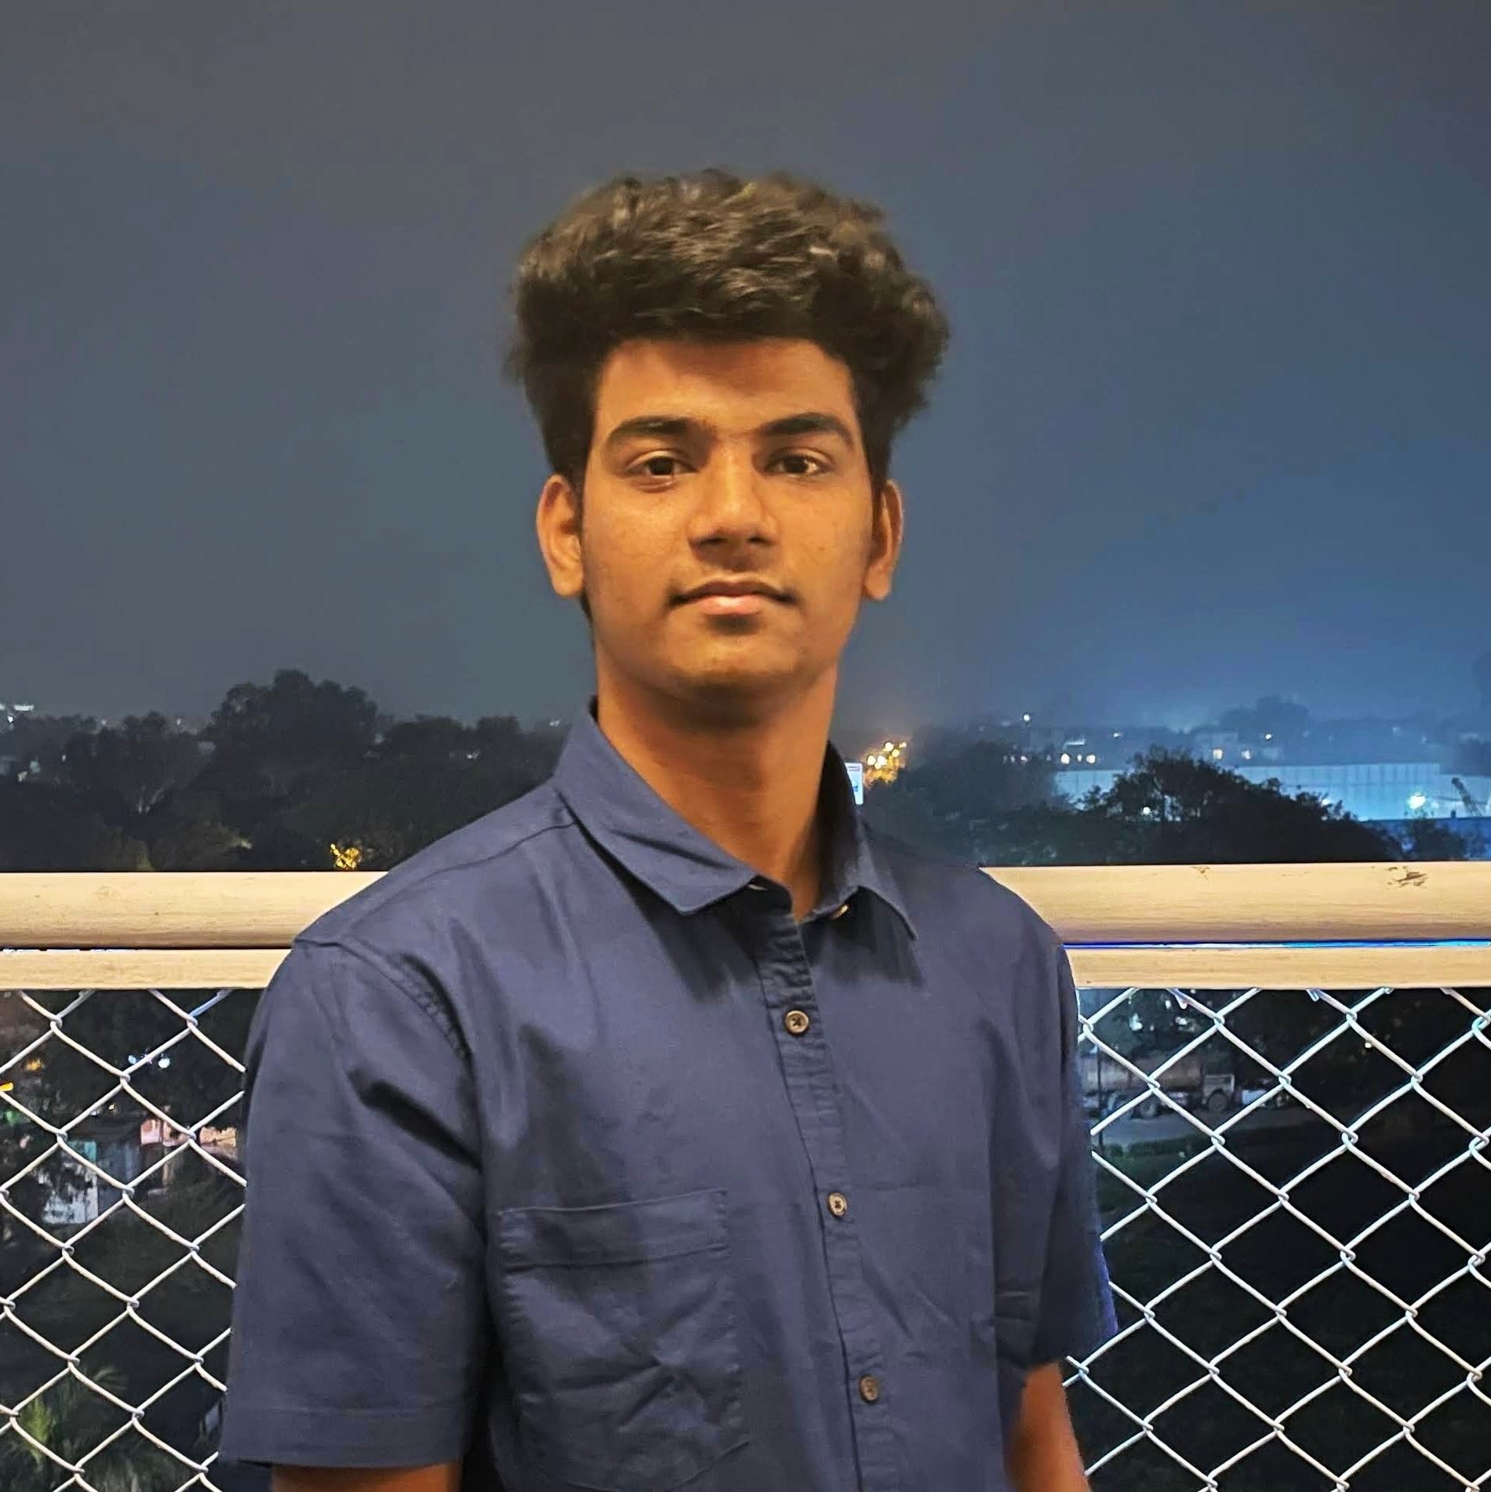
Vishnu Vardhan
2020480, Email: vishnu20480@iiitd.ac.in
DOB: Feb 24, 2003
Address: Hyderabad, Telangana, India
LinkedIn | GitHub
Education

Indraprastha Institute of Information technology, Delhi  B.Tech (CSE + Social Sciences)  2020 – Present | CGPA: 7.4  (till IVthSemester)
Narayana Junior College, Hyderabad India  Telangana State Board of Intermediate Education  2018 – 2020 | Percentage: 92
Gowtham Model School, Hyderabad India  Telangana State Board of Secondary Education  2020 | CGPA: 9.3

Skills

Expertise Area | Problem Solving, Data Structure and Algorithms, Web Development
Programming  Language | Java, Python, SQL, JavaScript, Node JS, R, HTML, CSS, C, Bash, Bootstrap, Flask
Tools and  Technologies | JAVAFX, Express JS, Python Pandas, MySQL, Git, GitHub
Technical Electives | Data Structure and Algorithm, Operating System, Database Management Systems, Advance Algorithm and Analysis, Computer Organization, Probability and Statistics, Discrete Mathematics, Linear Algebra, Econometrics, Convex Optimization

Experience

Creator Acquisition (Outreach) at Memboro  Memboro, Delhi India | Jul 21 – Present  Team Size – 20
- Built good public relations for the company, found new ways to contact people, and convinced them to join Memboro.

Co-Founder of Passious  Passious, Delhi India | Mar 22 – April 22
- Built good foundations for the startup and reviewed the development of Mobile Application and Website. Helped Strategizing the outreach and Marketing.

Projects

Regression Models | GitHub | Mar 22 – April 22
- Found the relation between health indicators such as the percentage of children demised from fever and data like agricultural conditions, tap water facilities for all districts of India.
- Cleaned and filtered huge data using R, Python Pandas, and MS-EXCEL techniques. Found the relation using Regression models, visualized and analyzed the data relations using histograms.

Will Hero | GitHubplementation of the existing cross-platform game Will  - An Implementation of the existing cross-platform game Will Hero using Java, OOPS, JavaFX, CSS. | Dec 2021  Team Size – 2
WORKING ON  - We are creating a fully functional web application related to online retail buying and selling platform using RDBMS  (MYSQL SQL), Frontend, backend development. | Team Size - 4
Positions of Responsibility

- Board Member Entrepreneurship Cell IIIT Delhi  - Ninja Entrepreneur Coding Ninjas  - Internshala Student Partner | Jul 21 – Present  Dec 21 – Present  Jan 21 -Present

Awards and Achievements

- Earned 3x of investment through affiliate marketing for a stock trading platform in 45 days (May 21 – Jun 21)

Interests and Hobbies

- Badminton
- Reading and watching Finance and political News

Declaration: The above information is correct to the best of my knowledge.
Vishnu Vardhan
Date: April 11, 2022

